**Game design document**

* 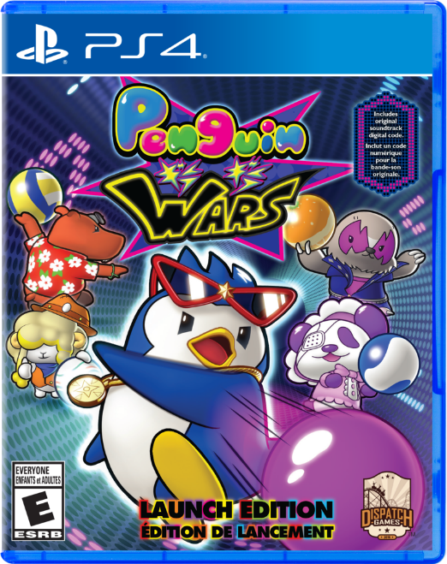**Game title**: Penguin Kun Wars

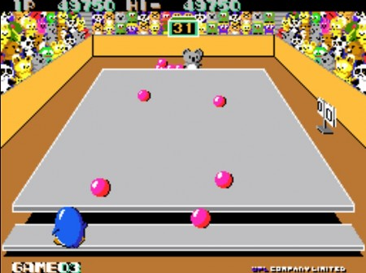

* **Studio that originally made the game**: UPL
* **Year it was release**: 1985
* **Team**: Deagu Fire Fist

Table of Contents

* **High Concept**

Penguin Kun Wars is a 3D quarter view game which play 1st-person. It is a shooting action game which cute penguin is throwing balls to opponent side by proceed with a tournament.

* **Game Flow**
* **Gama Mechanics and Rules**
* Move
* Penguin: Moving right-left using by direction keys. If he attacked with a by from his rival, he is fell down and struggling. If penguin lose, penguin is sweating with wings flapping.

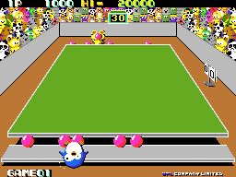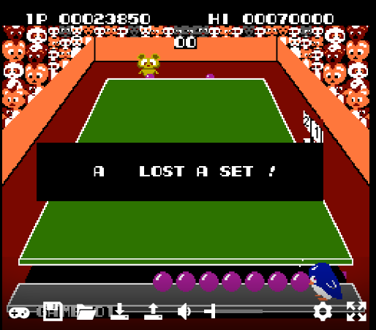

* Balls: Basically, they are thrown in a straight line. But if the balls hit each other or hit with obstacle, the direction is change. If the balls are in the same position, the balls fall off each other by itself. And if the balls hit the edge of the stadium, it bounces off.
* Rival: Same as Penguin, they are moving right-left. And if attacked by Penguin, he is fell down and struggling. Throw balls first in front of him.
* Obstacle: Moving right-left side. Even if it hits balls, its direction in not change.

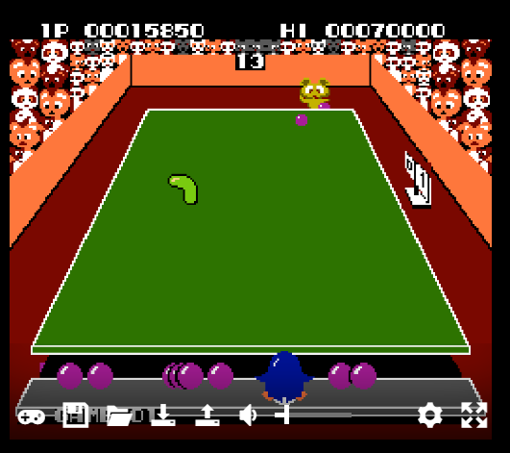

* Damage
* Penguin: If he attacked from balls, he can’t move for 3 seconds.
* Rival: If he attacked from balls, he can’t move for 3 seconds.
* Score Point
* If player throw the ball and hit his rival, player get 1000 points.
* Win
* Before the timer is over, throw all the balls to the opponent side.
* Keep less than rivals until the time is up.
* Lose
* Statistics
* Line-of-sight work
* **Game Characters**
* Rivals
* Obstacles
* **Game Resources**
* d